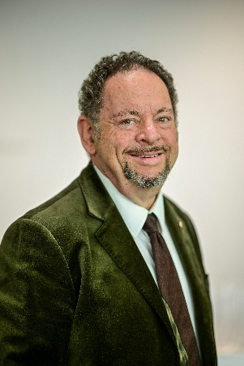
Dr David Ian Kram AM (PhD ARCM FRSA)
+61 412 114 725 (also WhatsApp)
davidkram@bigpond.com
www.davidkram.com

Dr David Kram AM, Artistic Director of the MTO-German-Australian Opera Grant and of Concertori Recordings (USA) and Senior Fellow, The University of Melbourne, is a distinguished conductor, artistic director, academic, composer and pianist in Australia, Europe and Asia. He is creator/artistic director/conductor of the AI-animated multimedia opera Brunnhailde and in 2024-25, conductor for Berlin Opera Academy.
The AM is for “significant service to the performing arts, to opera and chamber choirs, education”.
In June 2025 David presented a concert version of the world’s first multimedia opera integrating live performance with AI-assisted animated film. Auspiced by More Than Opera, this 100 minute adaptation of Wagner’s Ring Cycle for animated film, narration, three singers, saxophone quintet and piano was described as an ideal international touring vehicle. See www.brunnhailde.com. Promotion of the show to international festivals and opera houses continues in 2026, as well as overseas lecturing for Hayllar Music Tours and teaching and playing in Australia. He speaks four languages.
Recent guest conducting: Berlin Opera Academy Hänsel und Gretel, L’incoronazione di Poppea. Melbourne Opera, Tannhäuser, Lohengrin, Der Rosenkavalier and Wagner’s Ring Cycle. a CD with Prague Radio Symphony Orchestra; world premieres of Pecan Summer and Eumeralla for Short Black Opera and much choral conducting. He has conducted for Deutsche Oper and Komische Oper Berlin, also Braunschweig, Deutsche Oper am Rhein, Frankfurt, Karlsruhe, Köln, Nantes, Wiesbaden (including May Festival), ZDF-TV, Mexican and Malaysian National Symphony Orchestras.
Conducting positions include Kapellmeister, Stadttheater Basel; Erster Kapellmeister, Nationaltheater Mannheim; Resident Conductor, The Australian Opera, Music Director, State Opera of South Australia, Head of Opera at the Victoria College of the Arts, Melbourne (now Senior Fellow, Melbourne University). David’s PhD from Monash University focussed on Erich Wolfgang Korngold.
David is also a community leader in the fields of Rotary, Freemasonry, Progressive Judaism and Interfaith.

